Name: Ashok Rathod

Lab word: Working with Tables

Date: 4.12.19

Sqlzoo quiz score

1.

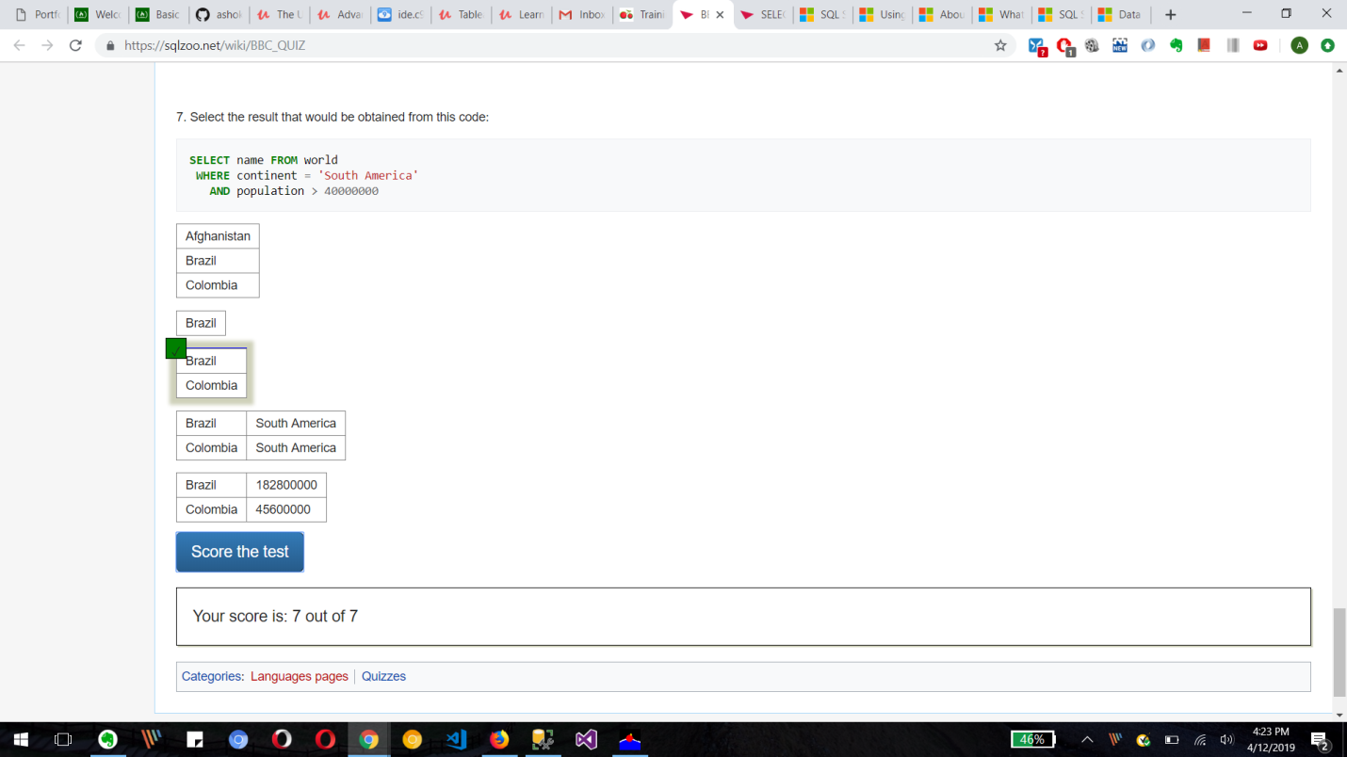

**2.**

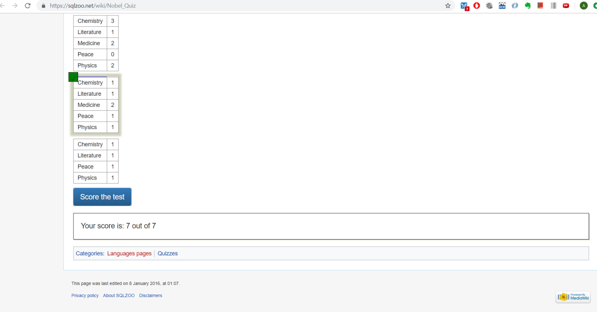

**Creating 2 tables with RIGHT click**

**Player table**

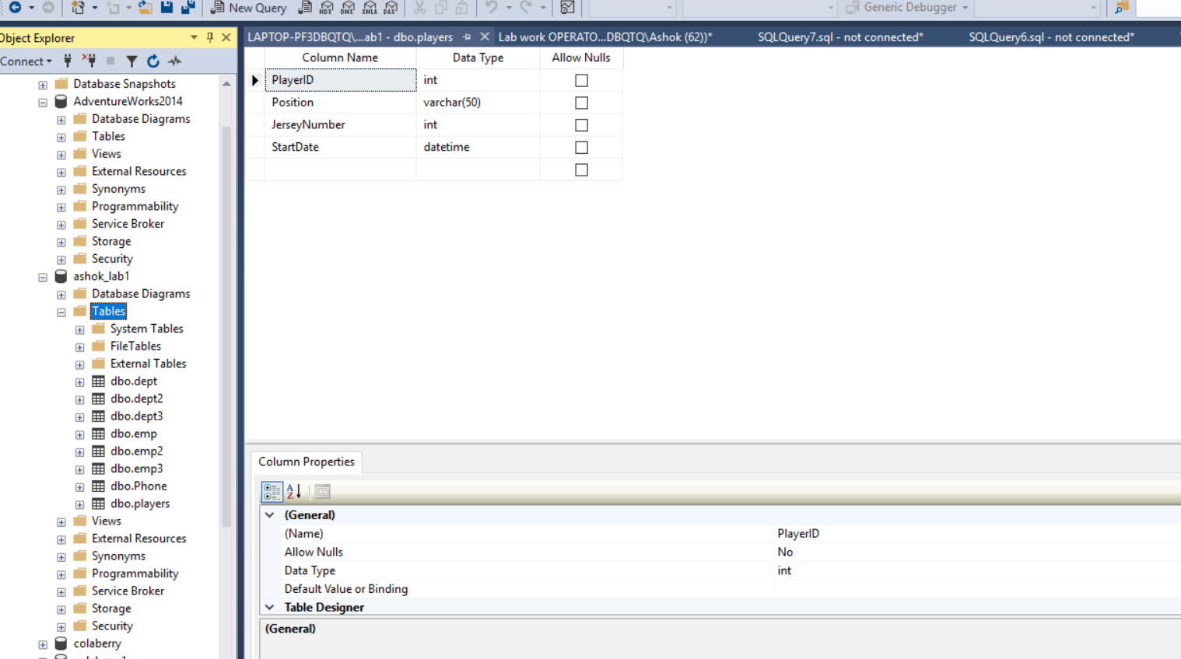

**Coaches table**

